**Linux** is a family of operating systems that use the Linux kernel. Widely spread, they provide many convenient tools for developers. Besides, Linux concepts became a source of inspiration for many ideas in programming languages.

The mascot of Linux is a penguin named Tux:



The choice of this symbol was not coincidental. *Linus Torvalds*, the creator of the operating system's kernel, had a similar toy in his childhood.

**A brief history of Linux**

Linus Torvalds*,* a Finnish software engineer, created the Linux kernel in 1991. He based his development on the **UNIX** operating system, which was popular at that time among many organizations and scientific institutions.

The first version of the kernel turned out to be very raw, with many defects and errors, so Linus decided to publish the source code openly on the Internet. As a result, many people got interested in Torvalds' idea and took part in the development of Linux. They started sending their improvements and corrections of the bugs found in the code.

**Distributions**

By itself, without software, the kernel is completely useless. However, it can be a basis for developing operating systems. Since the Linux kernel was posted free of charge, everyone could customize the system according to their needs and wants. Thus, it gave rise to distributions. **Distribution**is one of the operating systems based on the Linux kernel with many pre-installed programs, sometimes with a Graphical User Interface (GUI) out of the box. You have probably heard of some of them at least once: *Ubuntu*, *Fedora*, *Debian*, *Arch Linux*, *Gentoo*. This is far from a complete list of all the existing distributions.

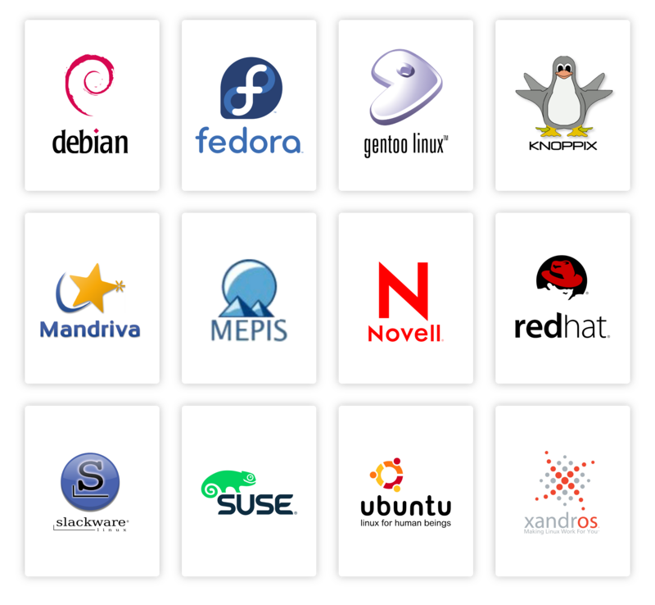

*Commonly used distributions*

Besides having some specific knowledge, you can build your own distribution, both from scratch or on the basis of already existing projects.

**Where and why people use Linux**

Linux kernel is free, customizable, very reliable, and undemanding to resources. Thanks to the well-thought-out file system, you can run distributions without a GUI. It also has extensive hardware support, as all free Linux drivers are built into the kernel. The scope of Linux is vast, much larger than that of all other operating systems. It works perfectly on ordinary personal computers, as well as on servers, embedded systems, and network software. Most of the supercomputers in the world work with Linux, for example, CERN. Even Android OS is based on the Linux kernel.

Such a large range of supported devices means excellent portability of programs. Often, we can run the same application on both an ordinary computer and a Linux-based smartphone with minimal effort.

**Conclusion**

So you took the first step in studying Linux. You have learned its benefits and realized how, with community support, it has become a major operating system on millions of devices.

Linux can provide a modern, stable, multiuser, and multitasking environment that will cost you nothing. All you have to do is pick the right distribution and, if you wish, customize it to suit your needs.

Why are there so many Linux-based distributions?

Hint (Linux is open source and free based distributed)

Linux was released under a license, which allows anyone to create their own distribution and distribute it freely

What should you do in order to adjust the Linux system to your wants and needs? Hint Linux has many distributions which are open source

choose a distribution and customize it

## Distros

What are distributions of Linux-based operating systems?

particular selections of different software, packaged with the Linux kernel by a community or a company

**What is Linux distribution?**

 Report a typo

A Linux distribution is

an operating system based on the Linux kernel

Linux-based operating systems are sometimes also referred to as Unix-like systems. Why is that?

They are in some ways, descendants of the original UNIX operating system and constructed similarly

What is the name of the operating system on which Linux was based on? UNIX

**Distributions**

What may distributions consist of?

**Correct answers:**

* **Kernel**
* **Graphical User Interface**
* **Pre-installed programs**

Choose the names of Linux distributions.

Debian Ubuntu Fedora

**Using Linux**

Where is Linux used?

**Correct answers:**

* **Embedded systems**
* **The Android OS**
* **Supercomputers**
* **Servers**
* **Network software**

### Explanation:

Linux is **highly versatile**, and it's used in a wide range of environments:

* ✅ **Embedded systems** – like routers, smart TVs, IoT devices
* ✅ **Android OS** – Android is built on the Linux kernel
* ✅ **Supercomputers** – over 90% of the world’s top supercomputers run Linux
* ✅ **Servers** – web, mail, database, and cloud servers commonly run Linux
* ✅ **Network software** – firewalls, VPNs, and other network tools are often Linux-based

So, **all listed options are correct**. Linux is basically everywhere except mainstream desktops, where Windows still dominates.

In what year did Linus Torvalds create the Linux kernel?

**Hint** Palindrome numbers are the easiest to memorize

1991

Select all the advantages of Linux:

✅ **Correct answers:**

* **Сustomizability**
* **Has free distributions**
* **High reliability**

### Explanation:

* ✅ **Customizability** – Linux can be tailored from the kernel to the desktop environment.
* ✅ **Free distributions** – Most Linux distros are free to download and use.
* ✅ **High reliability** – Known for stability, especially in server environments.

❌ **Support for all existing hardware** –  
This is **not always true**. Linux supports a **wide range** of hardware, but **not all**. Some hardware (especially very new or very old, or proprietary like certain Wi-Fi or GPU drivers) may not be fully supported out of the box.